Complex Networks
Assignment 1: Structural Descriptors of Complex Networks
MESIIA 2024-2025
Suiwen Dong
Mark Safronov

Net1.net

Network Statistics:
- Nodes: 5000
- Edges: 25000
- Min Degree: 6
- Max Degree: 16
- Avg Degree: 10.00
- Avg Clustering: 0.4141
- Assortativity: -0.0097
- Avg Path Length: 5.12
- Diameter: 8

Top Central Nodes:
- By Degree:
  - Node 1693: 0.0032
  - Node 1579: 0.003
  - Node 651: 0.003
  - Node 4891: 0.003
  - Node 41: 0.0028
- By Betweenness:
  - Node 4747: 0.0041
  - Node 2645: 0.004
  - Node 230: 0.0038
  - Node 4360: 0.0038
  - Node 1579: 0.0037
- By Eigenvector:
  - Node 651: 0.0286
  - Node 1937: 0.0265
  - Node 4526: 0.0256
  - Node 4398: 0.0253
  - Node 1939: 0.0252

CDDF
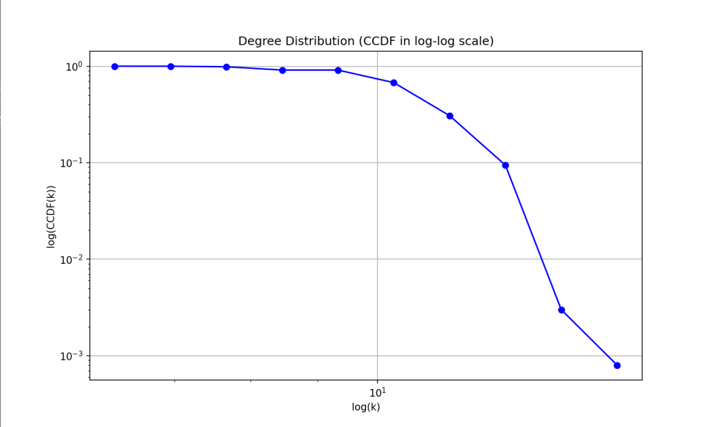

Conclusion
We think Net1 is built on a Watts-Strogatz model.
CDDF is not a power-law → excludes BA and our variant of CM.
CDDF has a hard drop → suggests Poisson distribution in non-log scale
Clustering 0.4141 – super high compared to other variants → excludes BA, ER and our CM variant.
Narrow degree distribution → may be ER but excludes BA and CM.
Centralities suggest no hubs → excludes BA and CM.

Net2.net

Network Statistics:
- Nodes: 5000
- Edges: 24873
- Min Degree: 1
- Max Degree: 24
- Avg Degree: 9.95
- Avg Clustering: 0.0021
- Assortativity: -0.0057
- Avg Path Length: 3.96
- Diameter: 7

Top Central Nodes:
- Degree:
  - Node 1581: 0.0048
  - Node 787: 0.0046
  - Node 52: 0.0042
  - Node 1990: 0.0042
  - Node 4917: 0.0042
- Betweenness:
  - Node 1581: 0.0033
  - Node 787: 0.0026
  - Node 4382: 0.0025
  - Node 52: 0.0023
  - Node 2375: 0.0023
- Eigenvector:
  - Node 1581: 0.0412
  - Node 3233: 0.0343
  - Node 787: 0.0341
  - Node 2375: 0.0337
  - Node 131: 0.0335

CDDF
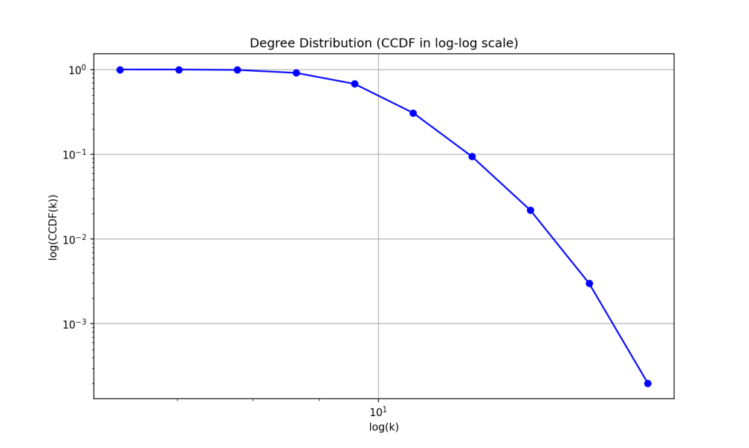

Conclusion
We think Net2 is built on an ER model.
CDDF plot is not a power-law – excludes BA and our variant of CM
Degrees range is very narrow.
Clustering is extremely low – excludes WS and BA
Top 5 centralities are almost evenly spread, which means no hubs.

Net3

Network Statistics:
- Nodes: 5000
- Edges: 23508
- Min Degree: 3
- Max Degree: 732
- Avg Degree: 9.40
- Avg Clustering: 0.0862
- Assortativity: -0.1339
- Avg Path Length: 3.01
- Diameter: 5

Top Central Nodes:
- Degree:
  - Node 5: 0.1464
  - Node 7: 0.1382
  - Node 2: 0.1252
  - Node 0: 0.124
  - Node 6: 0.111
- Betweenness:
  - Node 5: 0.1378
  - Node 7: 0.1277
  - Node 0: 0.1113
  - Node 2: 0.1093
  - Node 6: 0.0943
- Eigenvector:
  - Node 5: 0.2592
  - Node 7: 0.2417
  - Node 2: 0.2254
  - Node 0: 0.2254
  - Node 3: 0.207

CDDF

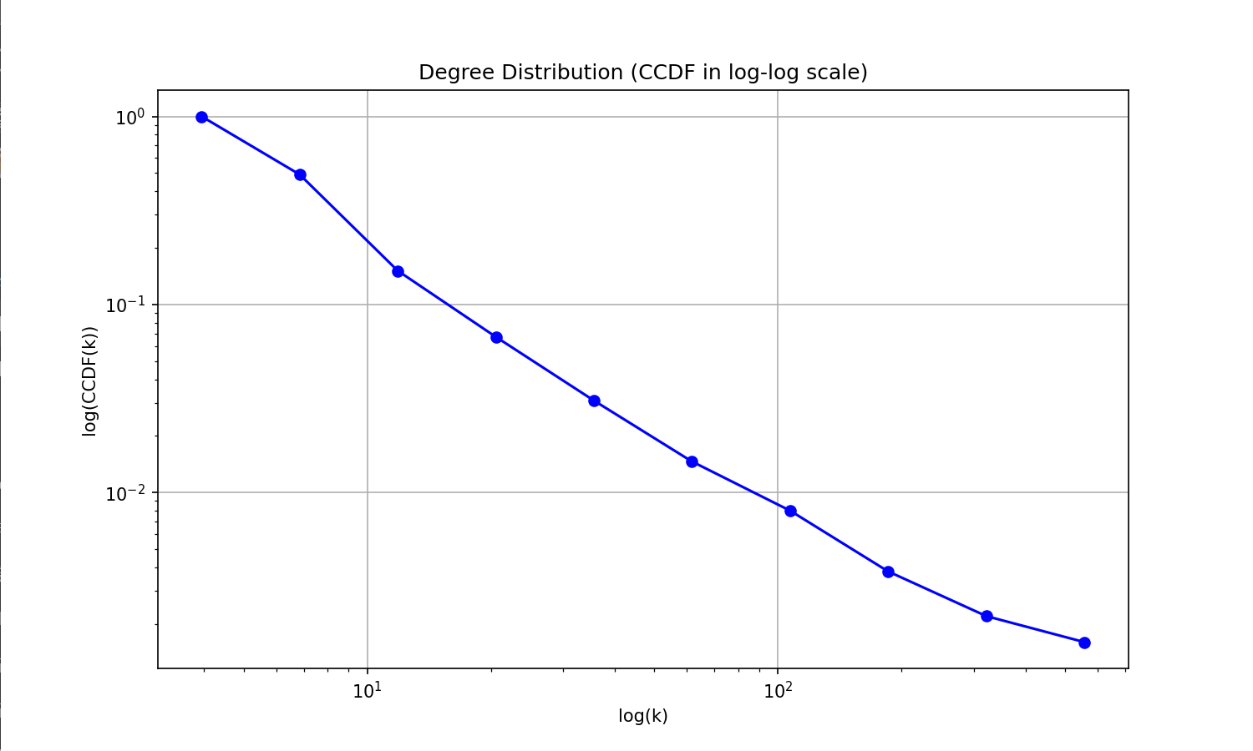
Conclusion
We think Net3 is built on Barabási-Albert model.
CDDF log-log plot is almost flat → power-law, scale-free network – matches BA and CM.
Clustering 0.0862 → too large for ER and CM, too small for WS.
Assortativity -0.1339 → hub-dominated network → BA and CM.
Super high max degree 732 → we have enormous hubs → too much for CM with

Net4

Network Statistics:
- Nodes: 5000
- Edges: 24975
- Min Degree: 5
- Max Degree: 210
- Avg Degree: 9.99
- Avg Clustering: 0.0107
- Assortativity: -0.0325
- Avg Path Length: 3.49
- Diameter: 5

Top Central Nodes:
- Degree:
  - Node 6: 0.042
  - Node 0: 0.0412
  - Node 9: 0.0408
  - Node 10: 0.0326
  - Node 8: 0.0324
- Betweenness:
  - Node 0: 0.0605
  - Node 6: 0.0576
  - Node 9: 0.0553
  - Node 8: 0.0391
  - Node 3: 0.0379
- Eigenvector:
  - Node 6: 0.2239
  - Node 0: 0.2234
  - Node 9: 0.2062
  - Node 8: 0.1741
  - Node 3: 0.1686

CDDF
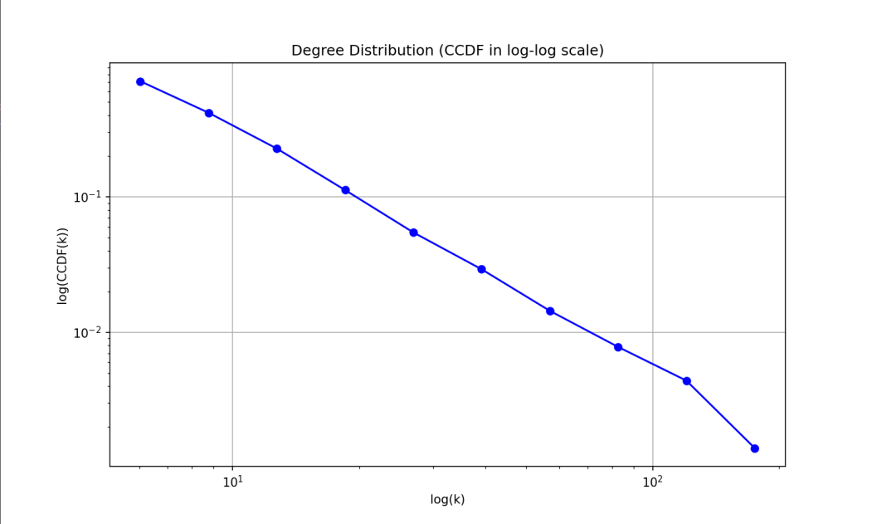

Conclusion
We think that Net4 is built by a Configuration model.
It was specified in the task that CM had .
CDDF plot is a flat slope → a power-law distribution and a scale-free network. So it’s not an ER model and likely not a WS.
Clustering coefficient 0.01 too low for WS with moderate rewiring and for BA. (compare with Net3)
Nodes 6, 0 and 9 have all centralities clearly dominating any other nodes.

An intermediary note on conclusions
In all four networks the diameter and the average shortest path length are not very informative because essentially all of them was a lot smaller than the network size, and the difference between their values is not representative enough to differentiate these models. However, these metrics surely would differentiate these four networks from other possible network construction models.

Net5

Network Statistics:
- Nodes: 200
- Edges: 465
- Min Degree: 1
- Max Degree: 10
- Avg Degree: 4.65
- Avg Clustering: 0.6107
- Assortativity: 0.5502
- Avg Path Length: 13.13
- Diameter: 35

Top Central Nodes:
- Degree:
  - Node 18: 0.0503
  - Node 33: 0.0503
  - Node 37: 0.0503
  - Node 170: 0.0503
  - Node 126: 0.0503
- Betweenness:
  - Node 177: 0.1955
  - Node 129: 0.1933
  - Node 78: 0.1926
  - Node 84: 0.1926
  - Node 104: 0.1923
There is no eigenvector centrality because the network is disjointed.

CDDF

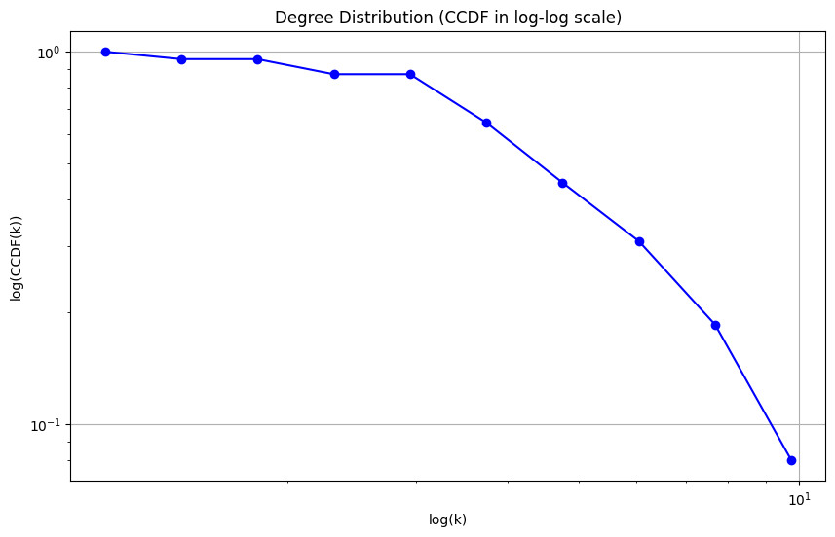
Network rendering
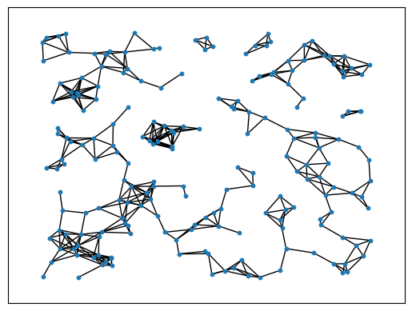
We clearly see that this network has:
- Disconnected components
- Sparse regions
- Dense cliques
Out of the blue the first idea which comes to mind is that this network was generated by something like multiple random walkers.

